|  |  |
| --- | --- |
| GEN AI LEARNING  **Complete Generative AI Learning – New Year Challenge** | WRITTEN BY: ALOY |

***Day – 8***

Ollama now supports structured outputs making it possible to constrain a model’s output to a specific format defined by a JSON schema. The Ollama Python and JavaScript libraries have been updated to support structured outputs.

Use cases for structured outputs include:

* Parsing data from documents
* Extracting data from images
* Structuring all language model responses
* More reliability and consistency than JSON mode

**Python**

Using the [Ollama Python library](https://github.com/ollama/ollama-python), pass in the schema as a JSON object to the format parameter as either dict or use Pydantic (recommended) to serialize the schema using **model_json_schema().**

For installation, the model locally runs

**ollama pull llama3.1**

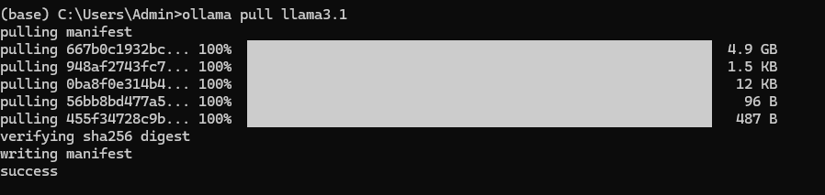

**Code:**

